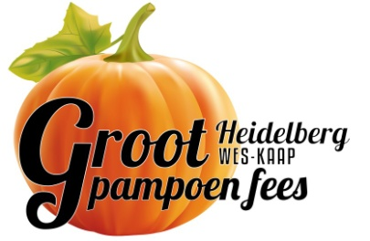
Sponsored by
FUN RUN

_____________________________________________________________________________________
ENTRY FORM * INSKRYWINGSVORM: 26 MARCH 2022

Surname/Van………………………………………………………………………………………………………………

Initials/Voorletters : …………………… Gender/Geslag: ……………… Age/ Ouderdom : …….…………

Physical Address/Fisiese Adres: ………………………………………………………………………………………………………………..………………..

…………………………………………………………………………………… Code/Kode: ………………………….

Email/Epos:….………………………………………………………………………………………………………………
Tick/Merk: Fun Run 5 km – R50 □ Fun Run 10 km – R80 □
Only one entry per participant /Slegs een inskrywing per deelnemer
RULES/REëLS :
- You must wear your race number during the race / Jou wedloopnommer moet tydens die wedloop gedra word.
- Payment – cash or card payment on day of event / Betalings - kontant of via kaart op die dag van wedloop.
- All entries will be at the starting point (show grounds) on race day from 07h00 – 7h30 / Alle inskrywings sal plaasvind by die beginpunt (skougronde) vanaf 07:00 tot 7h30.
- Participants must keep to the designated route as indicated / Deelnemers moet op die voorgeskrewe roete bly.
- Deelnemers moet ouer as 16jaar wees om aan die 10km wedloop deel te neem.
- Marshals, traffic officials and helpers must be always obeyed / Verkeers – en ander beamptes moet te alle tyegehoorsaam word.
- It is the responsibility of each participant to ensure that he/she is medically fit and healthy to participate in the event / Dit is die deelnemer se eie verantwoordelikheid om te sorg dat hy/sy fiks en gesond genoeg is om deel te neem.
- The organisers accept no responsibility for any accident or injury resulting from participation in this event / Die organiseerders aanvaar geen verantwoordelikheid vir enige ongeluk of beserings wat ‘n deelnemer weens deelname mag opdoen nie.
- The decision of the judges are FINAL / Die beslissing van die beoordelaars is FINAAL.
- Enquiries / Navrae: 083 226 3091
INDEMNITY / VRYWARING:
I agree that I am physically and mentally fit to participate in this event and assume all risks of such participation. I participate in the race at my own risk and hereby indemnify the organizers, officials and sponsors against any claim whatsoever that may result from my participation / Ek verklaar dat ek liggaamlik en geestelik fiks genoeg is om deel te neem en vrywaar die organiseerders, beamptes en helpers teen enige moontlik eis wat kan voortspruit uit my deelname aan hierdie byeenkoms.

…………………………………………. ………………………………………………..
Signature of Entrant Signature of parent/guardian if under the age of 18
Handtekening van deelnemer Handtekening van ouer as deelnemer onder 18 jaar oud is

………………......................
Date/Datum

This event is organized by Eureka Mills (Pty) Ltd on behalf of the Heidelberg Groot Pampoenfees 2022.
The aim is to raise funds for local community.

Heidelberg Groot Pampoenfees NPC 2015/050263/08
www.pumpkinfestival.co.za www.facebook.com/thegiantpumpkinfestival

